# 1.Introduction

### 1.1 Project Name

University career website.

### 1.2 Developer

Member 1: Li Cheng

Member 2: YuHan xue

### 1.3 Project development environment

#### 1.3.1 Hardware

Macbook Pro(Retina,Mid 2013)（Windows computer is ok ）

#### 1.3.2 Software

Intellij IDEA + macos high Sierra or Intellij IDEA +Windows 10

#### 1.3.3 DataBase

Mysql 5

#### 1.3.4 Development Technology

Springboot+javascript+html+css+Maven

# 2. Code explanation of each module in the System.

### 2.1 login module

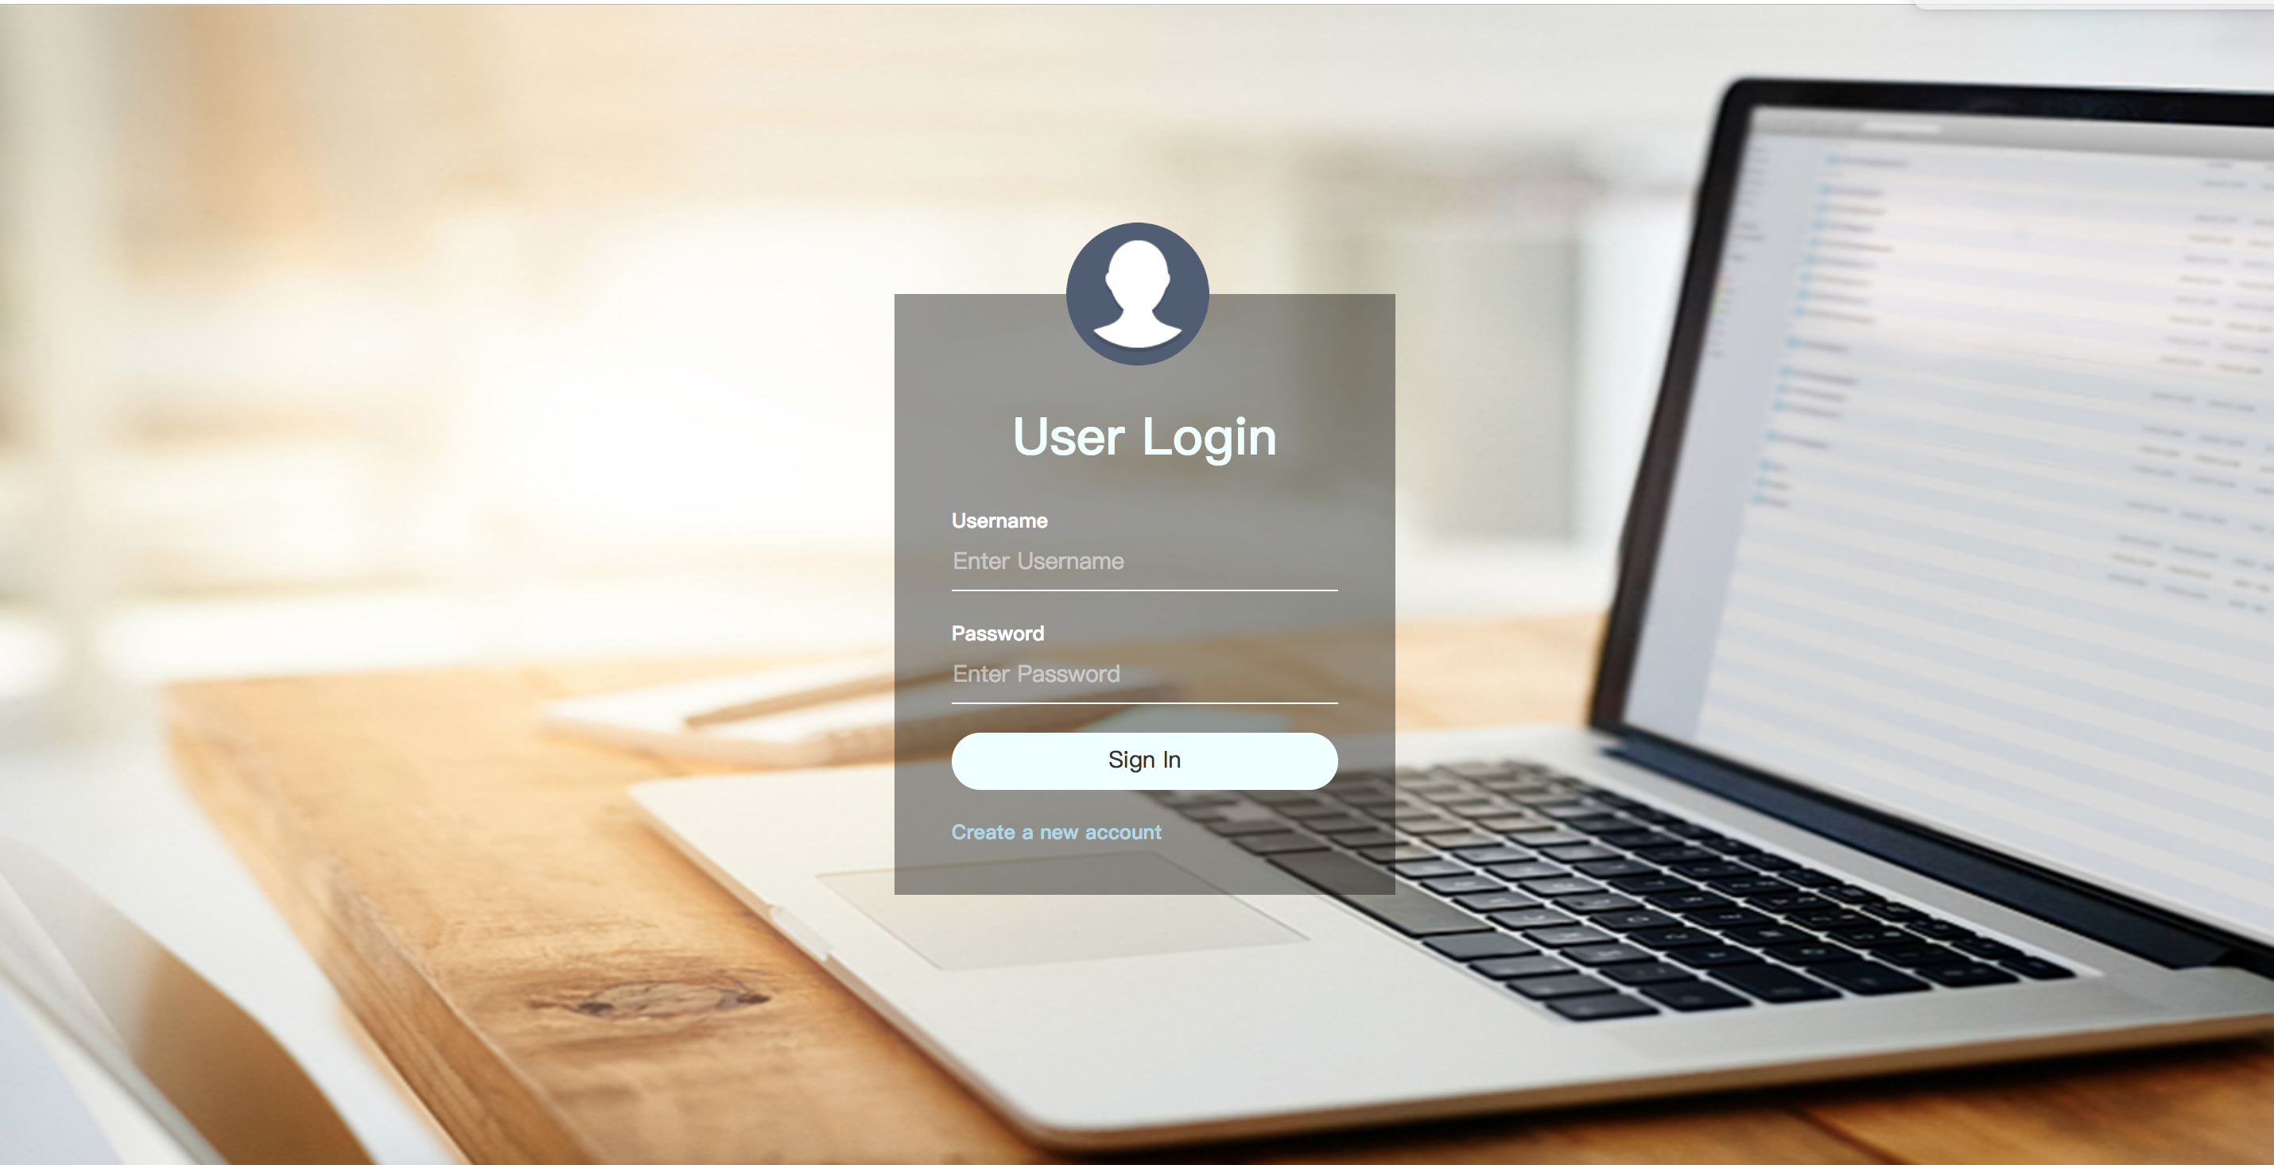

Key code in the login module.

2.1.1View part (WEB-INF/jsp/login.jsp) :

<**script type="text/javascript"**>  
 **function** *check*(){  
 **var** list = ***document***.getElementsByTagName(**"input"**);  
 **for**(**var** i=0;i<list.length;i++){  
 **if**(list[i].**value**==**""**){  
 *alert*(**"you should fill out the form"**);  
 **return false**;  
 }  
 }  
 **return true**;  
 }  
</**script**>

<**form method="post" action="${**pageContext.request.contextPath**}/login.do" onsubmit="return** *check*()**"**>  
 <**div**>  
 <**p**>Username</**p**>  
 <**input type="text" id="Username" placeholder="Enter Username" name="username"**/>  
 </**div**>  
  
 <**div**>  
 <**p**>Password</**p**>  
 <**input type="password" id="password" placeholder="Enter Password" name="password"**/>  
 </**div**>  
  
 <**div**>  
 <**input type="submit" value="Sign In"**/>  
 </**div**>  
  
 <**a href="${**pageContext.request.contextPath**}/register"**>Create a new account</**a**> <**br**>  
</**form**>

#### 2.1.2 Back-end part

a. (src/main/java/edu.monmouth.practicum/Controller/UserController)

@RequestMapping(**"login"**)  
**public** String loginview(){  
 **return "login"**;  
}

@RequestMapping(**"login.do"**)  
 **public** String login(@RequestParam(**"username"**) String username, @RequestParam(**"password"**) String password, HttpSession session){  
  
 User user = **userDao**.findByUsernameAndPassword(username,password);  
 **if**(user==**null**){  
 session.setAttribute(**"user_msg"**,**"error username or password"**);  
 **return "login"**;  
 }**else** {  
 **if**(user.getVerified()!=2){  
 session.setAttribute(**"rs_msg"**,**"you do not have right to use find resume function"**);  
 session.setAttribute(**"p_msg"**,**"you do not have right to use post resume function"**);  
 }**else** {  
 session.setAttribute(**"rs_msg"**,**"1"**);  
 session.setAttribute(**"p_msg"**,**"1"**);  
 }  
 **if**(user.getVerified() == 0){  
  
 session.setAttribute(**"user_msg"**,**"you need verify your email address"**);  
 **return "login"**;  
 }**else**{  
*// user.setVerified(1);  
// userDao.save(user);* session.setAttribute(**"user"**,user);  
 List<Job> jobs = **jobDao**.findByJobareaLike(**"%"**+user.getJobarea()+**"%"**);  
 session.setAttribute(**"jobs"**,jobs);  
 **return "Home"**;  
 }  
 }  
  
 }

### 2.2 register module

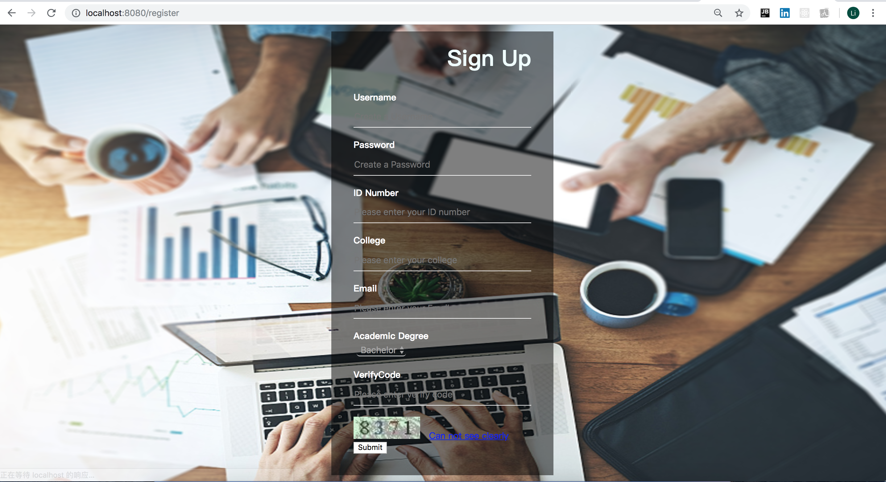

Key code in the register module.

2.2.1 View part (WEB-INF/jsp/register.jsp) :

<**script type="text/javascript"**>  
 **function** *changeImage*() {  
  
 ***document***.getElementById(**"img"**).**src** = **"${**pageContext.request.contextPath**}/imagecode?time="** + **new *Date***().getTime();  
 }  
 **function** *check*(){  
  
 **var** list = ***document***.getElementsByTagName(**"input"**);  
  
 **for**(**var** i=0;i<list.length;i++){  
 **if**(list[i].**value**==**""**){  
 *alert*(**"you should fill in the form"**);  
 **return false**;  
 }  
 }  
 **return true**;  
 }  
</**script**>

<**div class="SignUpBox"**>  
 <**h1**> Sign Up</**h1**>  
  
 <**form method="post" action="${**pageContext.request.contextPath**}/register.do" onsubmit="return** *check*()**"**>  
  
 <**font color="#ff0000"**>**${**email_msg**}**</**font**><**br** />  
 <**div**>  
 <**p**>Username</**p**>  
 <**div**>  
 <**input type="text" id="Username" placeholder="Create a Username" name="username"** />  
 </**div**>  
 </**div**>  
  
 <**div**>  
 <**p**>Password</**p**>  
 <**div**>  
 <**input type="password" id="password" placeholder="Create a Password" name="password"** />  
 </**div**>  
 </**div**>  
  
 <**div**>  
 <**p**>ID Number</**p**>  
 <**div**>  
 <**input type="text" id="id_number" placeholder="Please enter your ID number" name="id_number"** />  
 </**div**>  
 </**div**>  
  
 <**div**>  
 <**p**>College</**p**>  
 <**div**>  
 <**input type="text" id="college" placeholder="Please enter your college" name="college"** />  
 </**div**>  
 </**div**>  
  
 <**div**>  
 <**p**>Email</**p**>  
 <**div**>  
 <**input type="email" id="email" placeholder="Please enter your Email" name="email"** />  
 </**div**>  
 </**div**>  
  
 <**div**>  
 <**p**>Academic Degree</**p**>  
 <**div**>  
 <**select name="degree" id="degree"** >  
 <**option value="Bachelor"**>Bachelor</**option**>  
 <**option value="Master"**>Master</**option**>  
 <**option value="Phd"**>Phd</**option**>  
 </**select**>  
 </**div**>  
 </**div**>  
  
 <**font color="#ff0000"**>**${**errorMsg**}**</**font**><**br** />  
 <**div**>  
 <**p**>VerifyCode</**p**>  
 <**input type="text" id="checkCode" placeholder="Please enter verify code" name="checkCode"**/>  
 <**img src="${**pageContext.request.contextPath**}/imagecode" class="img" id="img"**/>**&nbsp;&nbsp;** <**a href="javascript:void(0);" onclick="***changeImage*()**"**>Can not see clearly</**a**>  
 </**div**>  
 <**div id="submit"**>  
 <**button type="submit" class="submit"**>Submit</**button**>  
 </**div**>  
</**form**>  
</**div**>

#### 2.2.2 Back-end part

a. (src/main/java/edu.monmouth.practicum/Controller/UserController)

@RequestMapping(**"register.do"**)  
**public** String Register(@Valid User user, HttpSession session, HttpServletRequest request) **throws** Exception {  
 String email = user.getEmail();  
 String RULE_EMAIL = **"^\\w+((-\\w+)|(\\.\\w+))*\\@[A-Za-z0-9]+((\\.|-)[A-Za-z0-9]+)*\\.[A-Za-z0-9]+$"**;  
 Pattern p = Pattern.*compile*(RULE_EMAIL);  
 Matcher m = p.matcher(email);  
 String checkCode = request.getParameter(**"checkCode"**);  
 Object cko = session.getAttribute(**"simpleCaptcha"**) ;  
 **if**(cko == **null**){  
 request.setAttribute(**"errorMsg"**, **"Too long time of this verified code, please rewrite verified code again！"**);  
 }  
 String captcha = cko.toString();  
 Date now = **new** Date();  
 Long codeTime = Long.*valueOf*(session.getAttribute(**"codeTime"**)+**""**);  
 **if**(StringUtils.*isEmpty*(checkCode) || captcha == **null** || !(checkCode.equalsIgnoreCase(captcha))) {  
 request.setAttribute(**"errorMsg"**, **"Verification code error!"**);  
 **return "register"**;  
 } **else if** ((now.getTime()-codeTime)/1000/60>5) {  
 *//验证码有效时长为5分钟* request.setAttribute(**"errorMsg"**, **"Verification code is invalid, please re-enter!"**);  
 **return "register"**;  
 }**else** {  
 **if**(m.matches()){  
 user.setVerified(0);  
 **userDao**.save(user);  
 session.setAttribute(**"user"**,user);  
 javaMail javaMail = **new** javaMail();  
 javaMail.sendmail(user.getEmail());  
 session.removeAttribute(**"simpleCaptcha"**);  
 session.setAttribute(**"user"**,user);  
 **return "login"**;  
 }  
 **else**{  
 session.setAttribute(**"email_msg"**,**"error email try it again"**);  
 **return "register"**;  
 }  
 }  
}  
@RequestMapping(**"register"**)  
**public** String RegisterView(){  
 **return "register"**;  
}

b. verify code (src/main/java/edu.monmouth.practicum/Controller/UserController)

@RequestMapping(**"imagecode"**)  
**public** String imagecode(HttpServletRequest request, HttpServletResponse response) **throws** Exception {  
 OutputStream os = response.getOutputStream();  
 Map<String,Object> map = ImageCode.*getImageCode*(60, 20, os);  
 String simpleCaptcha = **"simpleCaptcha"**;  
 request.getSession().setAttribute(simpleCaptcha, map.get(**"strEnsure"**).toString().toLowerCase());  
 request.getSession().setAttribute(**"codeTime"**,**new** Date().getTime());  
 **try** {  
 ImageIO.*write*((BufferedImage) map.get(**"image"**), **"JPEG"**, os);  
 } **catch** (IOException e) {  
 **return ""**;  
 }  
 **return null**;  
}